

PROPOSAL DOCUMENT

Vulnerability Assessment &
Penetration Testing (VAPT) Report

Marshan Technologies (Pty) Ltd

22nd August 2025

© Sautech (Pty) Ltd. http://www.sautech.net

TABLE OF CONTENTS

1 Executive summary 2
2 OVERVIEW 3
2.1 Purpose of Agreement 3
2.2 Key Outcomes 3
2.3 Business Impact 3
2.4 Recommendations 3
3 CONFIDENTIALITY & LEGAL DISCLAIMER 4
4 scope of testing 4
5 Methodologies used 4
5.1 Nmap / Zenmap 4
5.2 Tenable Nessus 4
5.3 Greenbone Enterprise 5
Stay One Step Ahead of Attackers 5
5.4 OWASP 5
6 RISK RATING MATRIX 6
7 SCOPE OF SERVERS 7
7.1 Web4.searchlightsoftware.co.za – 156.38.151.221 7
8 Reporting Conclusion 8
9 Auditors 9

Executive summary
The objective of this assessment was to identify security vulnerabilities, business logic flaws, and missing best security practices. The tests were conducted from the perspective of an attacker or malicious user, without causing any disruption to the functionality or performance of the application or network. Additionally, a comprehensive scan of the infrastructure was performed to simulate a real-world attack scenario, such as an internal network breach or exposure on a shared public subnet.
The assessment, including scans and testing, was carried out over seven (7) business days to ensure a thorough and methodical audit. These scans also examined unidentified connectivity options, such as packet SYN requests.

The overall results will be published below.
Recommendations are offered and mentioned throughout this document.

OVERVIEW

Purpose of Agreement
This penetration test and vulnerability assessment was conducted by Sautech (Pty) Ltd to evaluate the security posture of the client’s systems and identify potential risks that could impact business operations. The assessment was performed over the agreed scope, using industry-recognized methodologies and tools.

Key Outcomes
- The assessment identified vulnerabilities of varying severity (Critical, High, Medium, Low, Informational).
- Critical and High-risk vulnerabilities pose immediate risks and require urgent remediation.
- Medium and Low-risk issues should be addressed as part of ongoing security improvements.
- Informational findings highlight best practices and recommendations for strengthening defences.

Business Impact
Unresolved vulnerabilities may lead to:
- Unauthorized access to sensitive data.
- Financial and reputational damage.
- Potential non-compliance with regulatory requirements (e.g., POPIA, ISO 27001, GDPR, PCI-DSS).
- Service downtime and operational disruption.

Recommendations
- Prioritize remediation of Critical and High-risk vulnerabilities immediately.
- Implement structured remediation for Medium and Low-risk findings.

- Conduct a verification test to confirm that vulnerabilities have been resolved.
- Establish a continuous security program, including:
- Regular patching and system updates.
- Proactive monitoring of systems.
- Periodic penetration testing.
- Security awareness training for staff.

CONFIDENTIALITY & LEGAL DISCLAIMER

This report contains confidential and proprietary information belonging to Sautech (Pty) Ltd and the client organization. It is provided solely for the internal use of the client’s authorized stakeholders and may not be copied, disclosed, or distributed in whole or in part without prior written consent from Sautech.
The findings and recommendations in this report are based on the scope and conditions defined and agreed upon prior to the commencement of testing. This report reflects a point-in-time security assessment and does not guarantee the absolute security of the client’s systems. Sautech accepts no liability for any damages, direct or indirect, arising from the use of this report, including but not limited to financial loss, data compromise, reputational damage, or service disruption.
The client is solely responsible for implementing the remediation steps outlined in this report and for maintaining ongoing security controls after the conclusion of testing.

scope of testing

Security assessments include testing for security loopholes in the scope defined below. Apart from the following, no other information was provided. Nothing was assumed at the start of the security assessment. The following scope of servers were covered under the security audit:

- Web4searchlightsoftware.co.za – 156.38.151.221

Methodologies used

Sautech performed various audit techniques that includes the following:

Nmap / Zenmap

Nmap, short for Network Mapper, is a free and open source tool used for vulnerability checking, port scanning and, of course, network mapping. Despite being created back in 1997, Nmap remains the gold standard against which all other similar tools either commercial or open source, are judged.

To deploy Nmap, users originally had to have some advanced programming skills, with the introduction of the Zenmap tool for Nmap, which adds a graphical interface that makes launching the program and analysing the returned output it generates much more accessible.

Tenable Nessus

Nessus is a remote security scanning tool, which scans a computer and raises an alert if it discovers any vulnerabilities that malicious hackers could use to gain access to any computer you have connected to a network.
It does this by running over 1200 checks on a given computer, testing to see if any of these attacks could be used to break into the computer or otherwise harm it.

Greenbone Enterprise
Greenbone is the world’s most widely used vulnerability management provider.

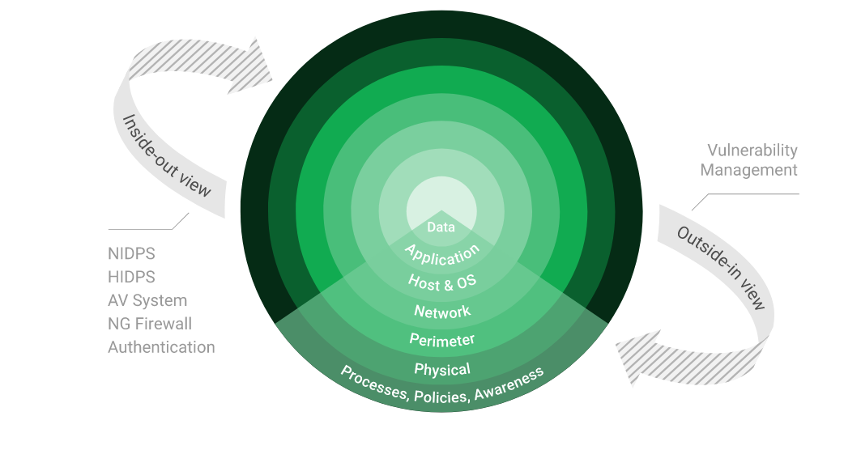

Stay One Step Ahead of Attackers
IT security is a process – Open Source vulnerability management provides the foundation. Once you know where the chinks are in your armor, you can do something about them.

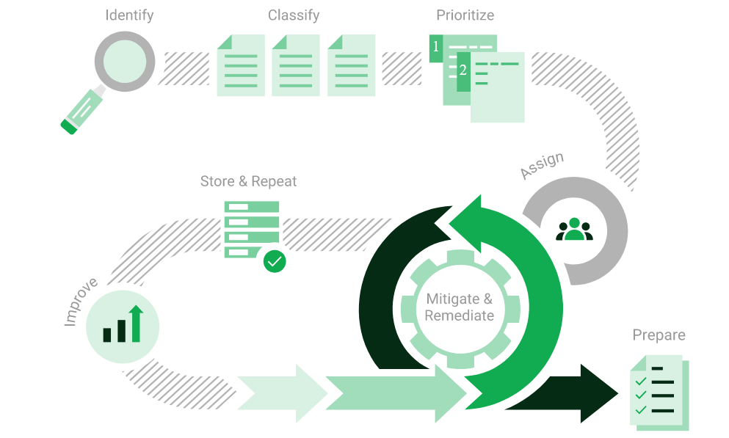

The process – from recognition to remedy and monitoring – represents a continuous cycle. You’ll always be one step ahead of attackers.

OWASP

The Open Web Application Security Project (OWASP) is an online community that produces freely-available articles, methodologies, documentation, tools, and technologies in the field of web application security.
The Open Web Application Security Project (OWASP) provides free and open resources. It is led by a non-profit called The OWASP Foundation.
The OWASP Top 10 - 2021 is the published result of recent research based on comprehensive data compiled from over 40 partner organizations.

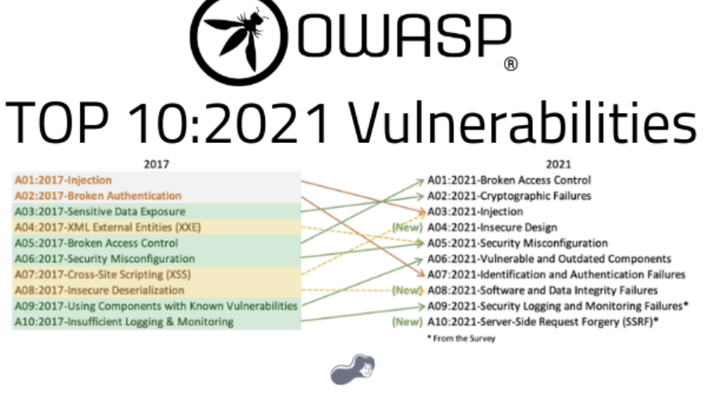

RISK RATING MATRIX

Risk Level | Description | Business Impact | Recommended Action
Critical | Vulnerability can be easily exploited and provides full system compromise, data theft, or unauthorized administrative access. | Severe disruption of operations, regulatory non-compliance, reputational damage, potential legal consequences. | Immediate remediation required. Treat as a top business priority.
High | Vulnerability is exploitable and may lead to significant compromise of data, applications, or systems. | High potential for financial loss, downtime, or data exposure. | Remediate as soon as possible. Assign ownership and track until resolved.
Medium | Vulnerability is exploitable under specific conditions or requires chaining with other weaknesses. | Moderate impact on business operations or data integrity. | Address during the next patch cycle or scheduled maintenance window.
Low | Vulnerability poses minimal risk and is difficult to exploit or has negligible business impact. | Low likelihood of direct compromise, but may assist attackers when combined with other flaws. | Remediation is recommended as part of long-term security improvement.
Informational | No immediate security risk; observations or best practice recommendations. | Minimal to no business impact. | Review and implement where applicable.

SCOPE OF SERVERS

Web4.searchlightsoftware.co.za – 156.38.151.221

We have performed the following types of scans / attacks on the server namely:

- Greenbone Enterprise - The Greenbone Report will be provided as a separate attachment.
- OWASP – The OWASP Report will be provided as a separate attachment.
- Port Mapping – Nmap / Zenmap (Open / Exposed Services) These were performed from unknown and known locations to test not just the security from the perimeter, but also include local network. Based on the port mapping open access to Public and Private, selected coordinated assessments were performed specific to the open connectivity received.
- Vulnerability Assessments – Tenable Nessus

Port Mapping – Nmap / Zenmap
Nmap can be used by hackers to gain access to uncontrolled ports on a system. All a hacker would need to do to successfully get into a targeted system would be to run Nmap on that system, look for vulnerabilities, and figure out how to exploit them.

The below screenshot demonstrates the open network port mapping:

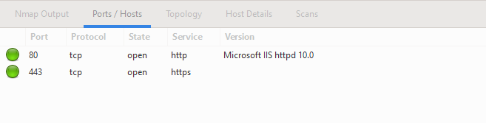

Remote Operating System Detection:

- Used Port: 80/tsp (open)
- Used Port: 443/tsp (open)

Vulnerability Assessment – Tenable Nessus
Multiple technologies were used to perform a vulnerability assessment, below is the summarised version of the relevant results:

We have attached the below “highlight” in a separate report so that you can click on the “Plugin” link to get the resolution.

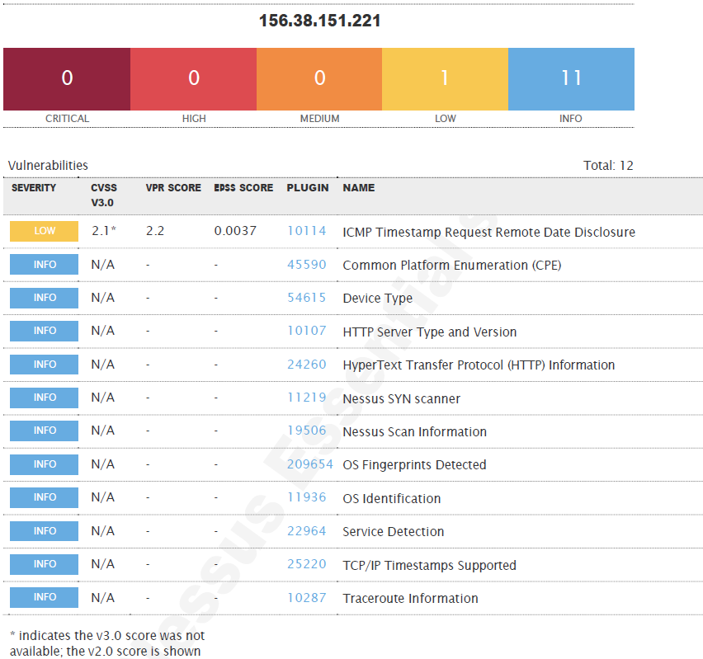

Reporting Conclusion

The penetration testing and vulnerability assessment conducted by Sautech have highlighted the current security posture of the client’s environment. The assessment identified vulnerabilities across varying severity levels, as defined in the Risk Rating Matrix included in this report.

After review of the Greenbone, Nessus, and OWASP scan results, as well as manual testing, we are satisfied with the overall outcome of the assessment. No critical or high-risk vulnerabilities were identified, and the results confirm that the client’s environment demonstrates strong security controls. At this stage, no remediation actions are required.

Three (3) addendum reports are attached to this report and should be read as one document:
- Web4.searchlight.co.za - (156.38.151.221) – Greenbone
- Web4.searchlight.co.za - (156.38.151.221) – Nessus
- Web4.searchlight.co.za - (156.38.151.221) – OWASP

With the following tests performed:
- Network scanning
- Known network attacks
- External HTTP and port exploits
- Vulnerability assessment on CVE

This assessment represents a point-in-time snapshot. The security landscape evolves rapidly, and new threats emerge daily.

Sautech therefore recommends continuing with the current security practices, while maintaining:

- Periodic verification testing to confirm that no new vulnerabilities emerge.
- A continuous security program that includes regular patch management, staff awareness, proactive monitoring, and scheduled penetration tests.

This report should be used in conjunction with the attached detailed technical findings as a record of the client’s current security posture. By maintaining these strong security practices, the client can continue to significantly reduce its exposure to cyber threats and improve overall resilience.

Auditors

These audits were concluded over a period of seven (7) business days.
We hereby confirm that the above information is true and correct:

22nd August 2025 – Krugersdorp, South Africa

_________________________ _________________________
Riaan van Jaarsveld Lukas Janse van Rensburg
Security Expert – CCSA / Certified Pen Tester Security Engineer

